FOOTBALL FRIDAY at the cafe!

The Ravens Need Your support!

Come Support the Baltimore Ravens as they take on the San Diego chargers!

FRIDAY, October 30th, at 11:15 am

Join us in the Café for a taste of Maryland and California!

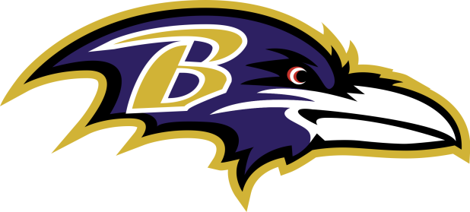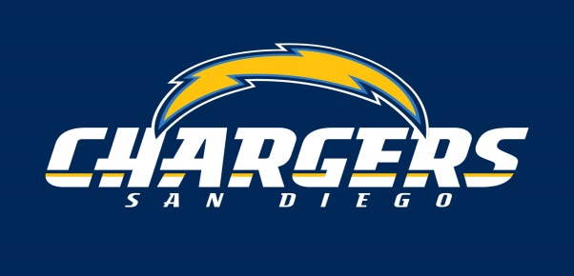

Crab Pretzels
Fish tacos
Wing Bar
Curly fries

GO RAVENS!

